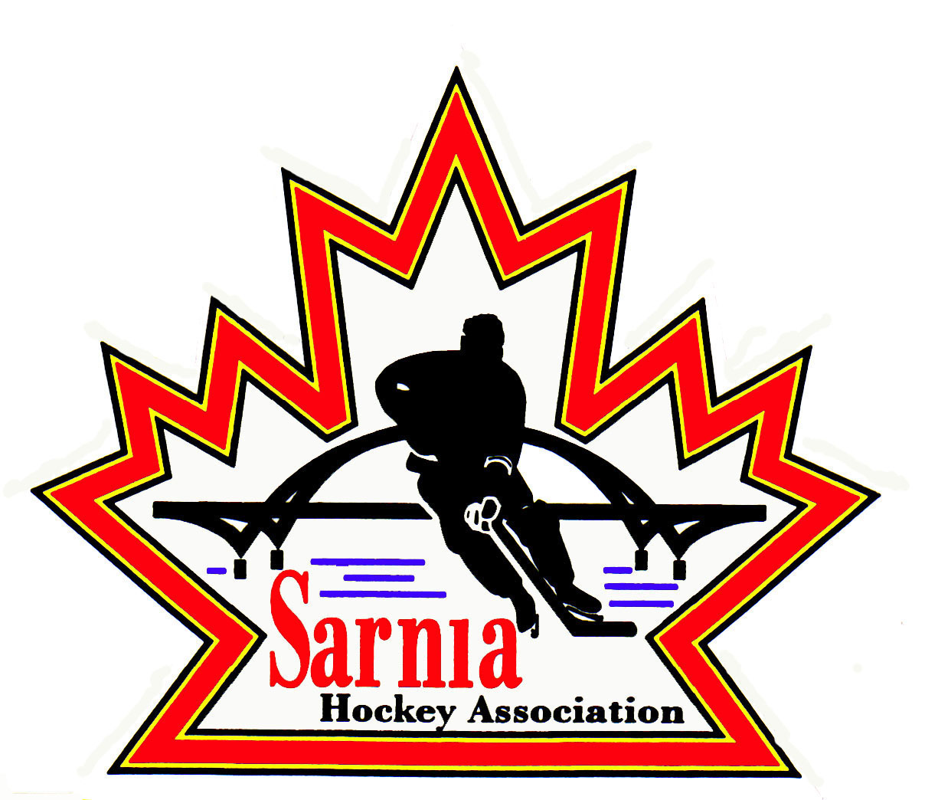

Sarnia Hockey Association

Minutes | Date: OCTOBER 16, 2024 | time 7:00 pm

Meeting called by | Paul Walsh, President
Type of meeting | Regular
Secretary | Kelly Lane, Recording Secretary

Welcome | Paul Walsh, President, and meeting Chair welcomed everyone and called the meeting to order at 7:08 pm.

ATTENDANCE | Heather Amaral, Andrew Beasley, Jerry Bernardo, Emily Brown, Darren Chevalier, Pat Forbes, Kelly Lane, John Mellor, John Ritchie, Wayne Scarrow, Tim Turner, Barb Walsh, Paul Walsh  Regrets: Ian Dunn, Dan Hunt, Linda Lauzon, Bonny Marcy, Don McGugan, Kyle Mellor, Jeffrey Needham, Ted Pendle, David Penner, Lesley Smith-Taylor, Kevin Taylor, Jason Teather

ACCEPTANCE OF MINUTES | MOTION #241016-001  “That the Minutes from October 1, 2024, be accepted as presented.” (J. Mellor/Ritchie)  Carried

TREASURER’S REPORT | Sitti  MOTION #241016-002  “That the Financial Report be accepted as presented.” (E. Brown/Ritchie)  Carried  - We are currently sitting at a healthy balance.  - SHA Grants of $23,250 which is the first installment of the Cousi Fund.  - We are also holding U9 Tier 1 and 2 sponsorship money until their bank accounts are set up.  - Registration for September is $131,000 including all outstanding balances. Also includes Rep assessment. Now at second installment with all to be finalized by December 1.  - We have received $13,000 so far for Rec league team sponsorships.  - Team loan repayments are also coming in.  - We gave a small extension to U18 AA because they don’t have their bank account in place yet.  - $5000 post-dated cheque was cashed for trophy expenses related to Silver Stick. It was post-dated from the Spring.

BILLS TO BE PAID | MOTION #241016-003  “That the bills be paid as presented.” (E. Brown/Bernardo)  Carried
  Recipient | Expense | Amount
  Planet Stitch  Darkhorse Goaltending  6x4 Goaltending  Darkhorse Goaltending  Darren Rogers | Rec jerseys and socks  Cousi Goalie Camp  Cousi Goalie Camp  Cousi Goalie training (shared ice approach)  PD Day – skater camp | $ 19,422.44  $ 600.00  $ 600.00  $ 750.00  $ 904.00

SILVER STICK | - Still collecting some funds.  - 20 U11/10U teams.  - 8 U18 teams.  - No issues with hotels at this point.  - Regional qualifiers are being completed. Last qualifiers are at Christmas with Petrolia being the last one.  - SHA website needs to be updated with correct dates. Our link from our website doesn’t go to right page. Web Director to update the link.

REC VICE CHAIR | SAFETY REMINDERS  - Reminder to coaches to have helmets on even when moving boards for cross ice.  - Reminder to players as well to keep helmets on even when in penalty boxes.  - Rec Equipment Director looking into some fixes for cross-ice boards both on ice and off ice. We need a wedge /buckle to lock the boards in.  - Reminder to Rec coaches regarding the change in ice cleaning which occurs now at the start of the hour or the quarter hour.  - Darren Rodgers coming this weekend for U11 and U13. All of the sessions are scheduled now.  - U21 and U18 want floods every two periods if possible. Ice is bad by the third period.  - Ice Director to communicate this to the city.

ICE DIRECTOR | - Tryouts are set for Select U11, U13 and U15 - Oct 18-20 plus teams have provided tournaments.  - U11 Select have practice figured out, just need to update website. Other teams will be looked at after tryouts.  - Have been asked to add information on PEP and Riley/Kaden goalie sessions.  - Will send out Spring Tryouts/September Extra ice, Refs and room rental invoices with copies to Treasurer.  - Reminder to all teams Rep/Rec teams regarding the changes in flood times.

CLINIC DIRECTOR | - Rep Director will ask Clinic Director to arrange a body checking refresh for U14 A team.  - Last year U14 A ran their own refresh clinic and U14 B needs it as well.  - We will combine both and invite the players that are AP’d.  - It is a requirement to offer a refresher.  - Will need to arrange for an instructor.

CORRESPONDENCE | - A number of emails received from Alliance Hockey regarding U17 Hockey Challenge.  - Tourism Lambton re U17 Hockey Challenge – news item re our members getting tickets for games they want.  - This will allow people to get first shot at tickets.  - Keep it as a top item in News Items.

NEW BUSINESS | LIVE BARN:  - This has been a struggle.  - Live Barn had a problem with Pat Stapleton due to power outage. They had local IT support running but no volume. Contacted them again today re this and they will look into this.  - Another issue – Rec league games were not being streamed.  - City is the owner of the arenas and didn’t want local associations running it. Turned it over to Sportle. They read ice schedule over our website and send it to Live Barn. Sportle messed up. This week they were misreading what Sportle was sending.  - Games are available for 30 days after live event.  - Having Live Barn is important as we have had to review issues.  - Question about whether we want all SHA ice streamed via Live Barn. Have had rep coaches request this also.  - Live Barn indicated it was possible. It also provides us opportunity to go in if there are issues or complaints. It is good for risk management and coaching.  - Majority will be parents looking at practices.  - There is a promo code SARN-LIVE provides a 10% discount on Live Barn.  MOTION #241016-004  “That SHA request Live Barn steam all of our practices and games if possible.” (P. Walsh/J. Mellor)  Carried  VSC’s FOR NON-ROSTERED REC TEAMS AFTER 3 WEEKS:  - We have now completed our initial 3 weeks and we don’t know all of the bench staff.  - Rec Directors to provide Rec Vice President or President with names so we can ensure who has completed VSC or who still needs to complete it.  - Google Sheets – were completed by Directors so those can be reviewed regarding requirements. This to be forwarded to Paul Walsh so he can review in HCR whether VSC has been completed.  - VSC portal will be locked on Nov 15 and any bench staff will be removed from rosters if requirements are not complete.  - There are still 4 people on board who haven’t completed volunteer registration and 3 who haven’t completed VSC’s.  - We need to get advice on whether those inactive members that haven’t met requirements pose a risk of insurance coverage to the Board.  - We will follow up with OHF. If it is a risk, we will need to take steps to remove them or convince them to complete requirements.  NEXT MEETING:  - Next meeting is Tuesday, November 5, 2024, at 7:00 pm at Clearwater Arena Lower Hall.

adjournment | MOTION #241016-005  “That the meeting be adjourned.” (Scarrow/Chevalier)  Carried

Paul Walsh Kelly Lane
President Secretary

